Nanoscience Technology Assay Housing
Progress Report

Group 12: Joseph Marmerstein, Eric Galles, Chase Walker
Client: Dr. James Hickman
October 19, 2014

Definitions
Important Acronyms:
µCCA: Micro Cell Culture Analog
MEA: Micro Electrode Array
MECA: Micro Electrode Cantilever Array
bioMEMS: Biomedical Microelectromechanical Systems
Important Terms/Variables:
Chamber: The area on which cells grow (includes, but is not limited to, area of MEA/MECA)
Housing/array: The combination of the entire design, including all chambers, channels, and other materials
Channel: Delivers fluid through the housing
Residence Time, t_{r}: The average time that a given liquid particle will spend inside the chamber
Hydraulic Resistance, R_{H}: Resistance to fluid flow generated by friction with chamber and channel walls
Shear stress, τ_{w}: The stress experienced on the cell surface parallel to the direction of flow
Viscosity, η: Measure of a fluid’s tendency to flow – for water (and cell growth medium), equal to 0.1$g/{cm*s}$
L, w, and h: The dimensions of the chambers

Need/Scope
For this project, the client is Dr. James Hickman at the University of Central Florida’s NanoScience Technology Center. Dr. Hickman’s group designs and constructs assays based on functional units of organ systems for drug screening. These assays can determine the effect of drugs on the functionality of the organ systems simulated through the use of various novel techniques created by Hickman’s group. Several of these assays have already been created, including models of human liver, motor neurons, skeletal muscle and cardiac muscle [1]. Because the human body is complex, a more complex system of drug screening is desired. Drugs do not just affect the targeted systems, but can have a variety of effects on the other, not-targeted tissues of the body. An integrated, whole-body system of individual assays could predict these effects with more accuracy, and, in doing so, assist in the validation of drugs. Effective drugs would progress in the design process with more confidence, and ineffective drugs filtered out before production with minimal economic loss. Additionally, testing drug candidates with human cells cultured on chips will decrease the number of animals used in live trials.
The goal of this project is to combine different individual units (micro cell culture analogs, or µCCAs), each consisting of a different organ tissue, so that they can interact and be studied as a single functional model. In order to combine the individual units into one whole-body system, there are two main areas of consideration that must be addressed: the microfluidic packaging and the electric/optical packaging of the system. Microfluidic considerations will include the physical layout of the individual unit and the fluid dynamics in the system. This system must be as physiologically relevant as possible so that the cells behave as they do in vivo. The electrical/optical considerations have to do with the measurement of the functionality of organ tissues by bioMEMS devices. Each individual unit will contain a microelectrode array (MEA) or micro electrode cantilever array (MECA). Multiple electrical inputs and outputs are required for this device, as well as microscope access. Furthermore, the skeletal and cardiac muscle subunits must be accessible by laser for force analysis. These two areas of consideration are not mutually exclusive, as the subunits must be organized in a layout that can be easily observed by microscope and laser, and the inputs and outputs are both accessible and organized.

Design Requirements
For this project, the functional organ models have already been created and tested.
Additionally, some groups have created multi-organ systems using a variety of methods [2]. However, in order to create a multi-organ system that can be observed in great detail, certain design specifications must be met. This project will focuses on four cell types: cardiomyocytes (heart muscle cells), hepatocytes (liver cells), motoneurons, and skeletal muscle cells. Each organ model presents unique challenges, and other factors involve the system as a whole and the interaction between the subunits.
All of the µCCA’s use a bioMEM system to analyze and observe certain cell properties. Both the hepatocytes and the motoneurons use MEAs for this purpose. These arrays are mounted on a square that is 15mmx15mmx500µm, and contain 16 electrodes and one reference. Both the skeletal muscle and heart muscle systems employ MECAs that allow the researcher to determine contractile strength of the muscle cells. The cantilevers are the same size as the MEAs, but require laser access from the bottom of the chip in order to measure the force developed in the muscle [3]. Furthermore, all four chambers will need to be accessible by optical microscope from the top of the chip for monitoring cell viability during the cell lifetimes.
When designing the individual units and chambers, there are certain constraints that must be met. First, each chamber must be at least as large as the MEAs/MECAs (and therefore greater than 15mmx15mmx500µm). In addition, the chamber should be constructed so as to be as physiologically realistic as possible – this means that the liquid residence times, shear stress, and liquid-to-cell ratios should all be within physiological ranges, as defined in Table 1.
Additionally, it is better if the organ subunits interact in a physiologically meaningful way. The ratios of cells in this device should mimic those in the body. By using the average cell numbers of different organs, we can estimate that the cell ratios for this array would be approximately 1 motoneuron: 4167 skeletal muscle cells: 3.33 * 10⁴ cardiomyocytes: 4.02 * 10⁶ hepatocytes. Additionally, not all organ systems receive equivalent blood flow in the human body. Therefore, the array must have the capability of modulating the flow rate to individual units such that the flow ratios are 1(motoneurons): 1(cardiomyocytes): 4.44(skeletal muscle): 7.33(hepatocyte). Unfortunately, it is not feasible to create a system that matches the above cell ratios – doing so would require chambers far too large for this application (dimensions on the order of meters). It is, however, possible to match the fluid flow ratios listed.
In order to quantify the design specifications, metrics were created (Table 1). These metrics were chosen in such a way that they reflect the relative importance of different system parameters – shear stress being the most important (as cells behave differently under non-physiological shear stresses), and liquid-to-cell ratio being relatively unimportant.

Table 1 - Specific design requirements with metrics
Specification | Metric
Physiological Shear Stress | 2 dynes/cm² (within 5%)
Physiological residence times | Within 10% of physiological values
Reasonably small Dimensions | Maximum 3x3cm chambers, minimum 1.5x1.5 cm
Physiological liquid:cell ratio | 1:2 is ideal, no greater than 5:1
Physiological relative flow rates | Within 5% of physiological values
Laminar flow | Re < 2300
Optical (microscope) access for all chambers | Reflective mode, 0.8x-35x
Laser access for MECAs | 633 nm wavelength through glass

Design Alternative Analysis and Selection
The design alternatives were evaluated by dividing the device design into sections and exploring alternatives for each section. The sections considered are the layers present in the silicon chip, microfluidic branch point, chamber shape, method of laser access, use of microstructures, and method of optical access.

Layers
In creating a microfluidic device, there are several possible ways to arrange the chambers and channels on the chip. One possibility, implemented by Sung and Shuler [5], is to have all channels and chambers etched into a single layer, as shown in Figure 1a. This solution is the most simple, and requires the least amount of materials. A second solution, also proposed by Sung and Shuler [6], is to have two layers, the top one with only the channels machined into it, and the second layer with all the chambers in it (Figure 1b). This design facilitates easier removal of the chamber layers for examination of the cultured cells. The final alternative is to have a top layer with two of the chambers and their corresponding channels, and a second layer with the other channels and chambers underneath it (Figure 1c). This has the most efficient use of chip space, allowing for a smaller array, less materials used, and higher electric density of bioMEMS.
In our device, the biggest design consideration is easy access to the cells to assess viability. Ideally, the cell viability can be determined by optical viewing of the chambers while the device is fully assembled. This means that the 2 chamber multilayer solution is not viable, as all 4 cell chambers must be visible from the top of the device. This problem is also present in the multi-layer channel/chamber approach due to the top layer covering some areas of the cell chambers, since this device is not designed to be disassembled once testing begins. In microfluidics, the biggest advantage that a multi-layer design offers is the ability to model membranes and barriers between organs using microfabricated architecture. In this project, no barriers or membranes will be involved, making a multi-layer approach unnecessary. The single layer design offers greater accessibility to the cell chambers, as well as a simplified fluid flow pathway, since there is no vertical component to the flow. For these reasons, a single layer solution was selected for this project. A Pugh chart for this decision is shown in Table 2. In this chart, the ease of laser and optical access are the most important design considerations. Note that both the single layer and multiple etched layer designs have higher weighted totals; in this case, the single layer design is preferred largely because it is easier to produce.

Table 2 - Pugh chart displaying alternative designs for the layers housing array
 | MEA/MECA Access | Laser Access | Optical Access | Production Simplicity | Size/  Footprint | Client’s familiarity with production/use | Total
Weight | 2 | 5 | 5 | 4 | 3 | 1
Single Layer | 8 | 10 | 10 | 10 | 7 | 10 | 187
Multiple etched layers | 9 | 10 | 10 | 7 | 7 | 10 | 177
Multiple chamber layers | 10 | 10 | 4 | 4 | 10 | 0 | 136

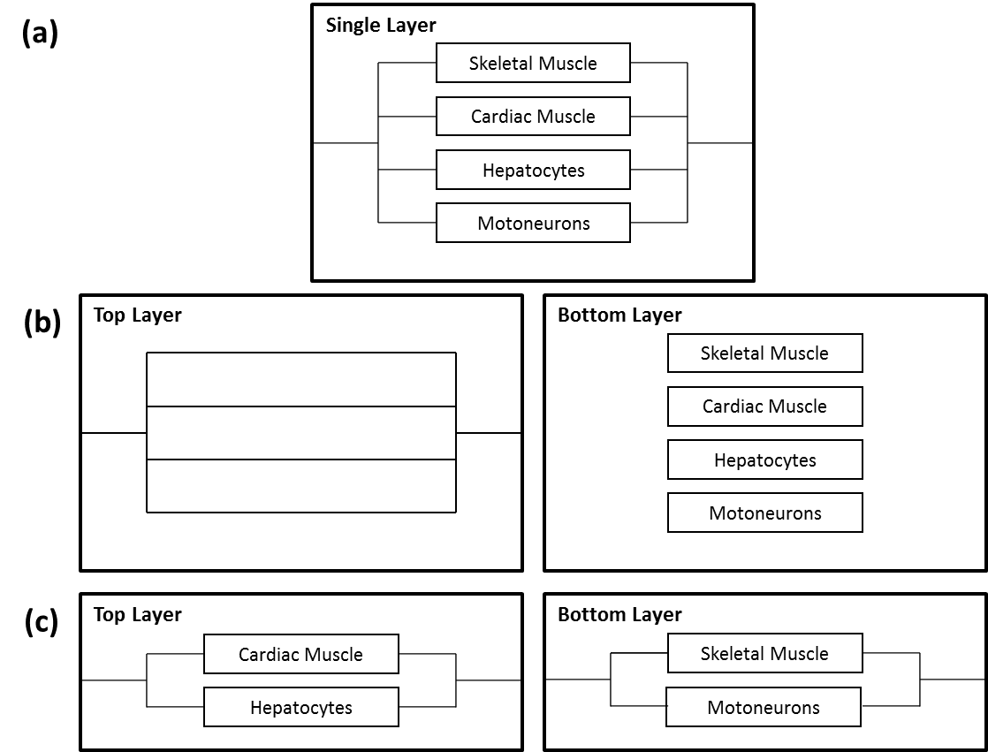
Figure 1-Possible layer solutions (a) Single layer design (b) multiple etched layers (c) multiple chamber layers.

Branch Point
Another design element to be considered is the branch point of the fluid flow. Since the four cell types are all put in parallel, the fluid flow must split into four branches at some point. There are three main ways this can be accomplished – a reservoir of fluid with four separate pumps (one for each branch, as shown in Figure 2a), a single pump, which branches before the array inlet (Figure 2b), or a single pump, with the branch point after the inlet (branching into separate microchannels, as shown in Figure 2c). Any branch point before the inlet will add a relatively large amount of tubing to the system, making it harder to set up, move, and most importantly, more difficult to image and analyze. In addition, control of hydraulic resistance is less precise when using macroscopic tubing – the machined microchannels can be controlled with more accuracy. Therefore, for simplicity and accuracy, having a branch point after the chamber inlet (and re-joining before the outlet) is best for this design. A Pugh chart for this decision is shown in Table 3. In this case, having the branch point inside the housing is clearly the best choice.
Table 3 - Pugh chart for the different branch point locations
 | Easy to Machine | Easy to Setup | Easy to move (e.g. to image) | Cost | Space | Precise Resistance Control | Total
Weight | 2 | 4 | 5 | 2 | 4 | 5
Before Pumps | 10 | 1 | 1 | 1 | 1 | 6 | 65
Before Housing | 10 | 5 | 3 | 10 | 6 | 6 | 129
In Housing | 1 | 10 | 8 | 8 | 10 | 10 | 188

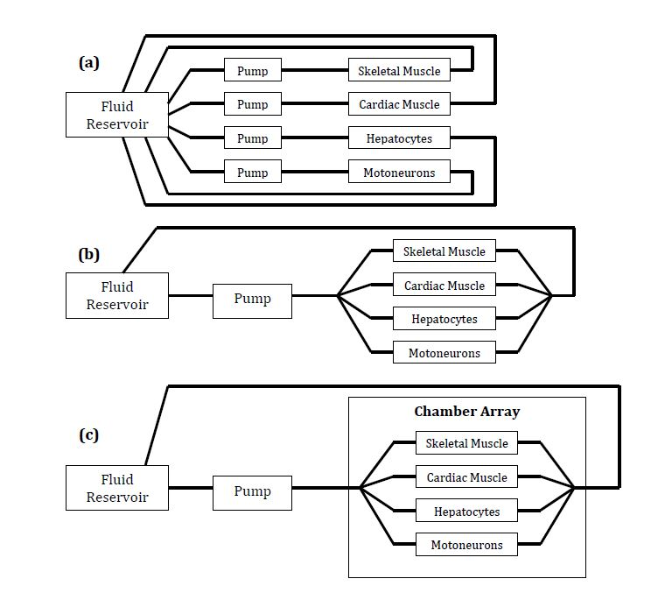
Figure 2- Possible branch point solutions: (a) branch point before pumps (b) branch point before housing (c) branch point in housing

Chamber Shape
Another set of design alternatives to consider for this device is the shape of the chambers that contain the cells. The chamber needs to accomplish the following tasks: to culture cells, to house the silicon chips used for cellular functional measurement, and to direct fluid flow uniformly across the cells for drug metabolism. There are three shapes considered for the chambers, all of which have a rectangular cross section perpendicular to the flow.
The first shape considered is the circular chamber, shown in Figure 3a. This designed was proposed by Sin et al. for a µCCA of the lung [4]. The round chamber was chosen because of the need to mimic the shape of commercially available membranes for the simulation of gas exchange in the lungs. This functionality is not needed in this design, as gas exchange will not be a factor considered. Other downsides include that the flow through a circular chamber is less uniform than the other shapes. Also, because the silicon chips used to culture cells are square, more surface area than necessary would be needed to fit the chips. This makes the circular chamber a poor choice for this device. If the device is expanded to include a lung chamber in the future, this shape can be re-discussed.
The next shape to consider is a hexagonal chamber, shown in Figure 3b. This shape is the shape used most frequently in µCCA's and is therefore the most familiar to the users. The hexagonal shape helps disperse the medium slightly throughout the chamber, and the rectangular portion would fit the silicon chips without need for extra surface area. Also, the dimensions of this shape are more easily evaluated for parameters such as shear stress and residence time. However, the fluid still mostly flows through the center of the chamber, directly from inlet to outlet.
The third shape, proposed by Sung et al., is a rectangular chamber with multiple inlets and outlets [5], as shown in Figure 3c. The rectangular shape has the same advantages as those mentioned before. Also, the flow split before the chamber means that of all the shapes, the flow is most distributed in this chamber. This makes this shape more preferable than the hexagonal shape, despite being less frequently used. This shape is the one chosen for the design of all four chambers in the device. A Pugh chart for these design alternatives is shown in Table 4. Both hexagonal and rectangular chambers are good options, but rectangular chambers are slightly preferred due to more uniform flow.
Table 4 - Pugh chart for different chamber shapes
 | Uniform Flow | Fit to MEA/MECA | Ease of parameter calculations | Ease of production | Total
Weight | 5 | 4 | 2 | 2
Circular | 3 | 4 | 4 | 9 | 57
Hexagonal | 6 | 10 | 7 | 9 | 102
Rectangular | 8 | 10 | 7 | 7 | 108

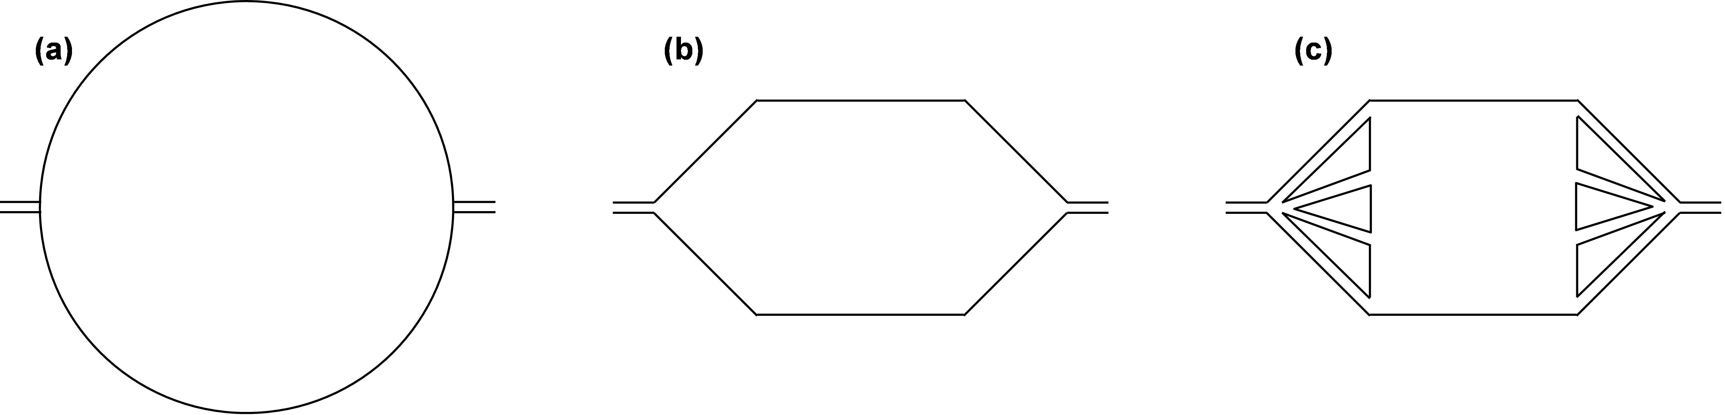
Figure 3- Possible chamber shapes (a) circular (b) hexagonal (c) rectangular

Laser Access
Another set of design alternatives for this device is the method of access by laser for two of the four chambers. The laser needs to interrogate the underside of the MECA’s for functional analysis. This is achieved by reflecting the laser off the bottom of the silicon cantilevers and then onto a detector. When the muscle cells contract, they produce a bending moment on the cantilever that deflects the laser, which is then recorded by the detector. What is needed by our device is a pathway for the laser to travel so that is can reach the underside of the MECA’s unimpeded. This was done by Wilson et al. by sealing the bottom of the MECA to a glass coverslip with a silicon gasket, providing a clear material that the laser could travel through [3]. In their design, the MECA was not subjected to microfluidic flow and was not contained in a device with other chambers. This device is complicated by the fact that other chambers need access, while others do not. Three designs for laser access have been conceived, and are shown in Figure 4.
The first alternative, shown in Figure 4a, is to cover the entirety of the underside of the µCCA housing with glass. The chambers would be etched completely through the housing, so that the bottom of each chamber is created by the glass. This allows access by laser to every chamber in the design, necessary or not. This design is the most simplistic in fabrication and setup. However, it uses more glass than the other designs and requires the entire housing to be sealed against the glass, rather than the individual chambers.
(a)
(b)
(c)
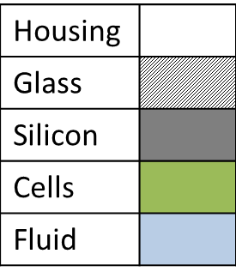

Figure 4 - Possible methods for laser access: (a) single glass bottom (b) multiple glass pieces, mounted from below (c) multiple glass pieces, mounted from above.
The second alternative, shown in Figure 4b, is to etch only the chambers needing interrogation through the housing, and etching a larger surface underneath those chambers for the placement of glass. This design allows for the placement of glass only over isolated chambers, requiring less glass and seals only around those chambers. However, this design would require a multiple step etching process, as the undersides of the housing needs to be etched, and would be require a thicker housing than the first design.
(b)
(c)
(a)
The third alternative, shown in Figure 4c, is to etch neither of the chambers completely through the housing. A thicker housing could be used, with deeper chambers by the width of the glass. The chambers needing access would have a window etched through the housing at the bottom of the chamber. A piece of glass the size of the chamber would be placed underneath the silicon chip, but inside the chamber. This design uses the least glass and only needs sealed around two chambers. Also, it can be completed with one etching. The downsides are that a thicker housing is needed than in either design, costing more money; it is more complex than the other two designs; and it has a smaller access range for the laser, limiting the range of angles at which it can be interrogated. These considerations were made into a Pugh chart, seen in Table 5.
Figure 4 – Possible methods of laser access.
The first alternative was chosen due to its simplicity of fabrication and ease of setup, and due to its cost. Glass is cheaper than the housing material, so the extra glass used in that design reduces the cost of the device.
Table 5 - Pugh chart for different chamber shapes
 | Cost of materials | Range of Laser Access | Ease of Setup | Production Simplicity | Total
Weight | 5 | 3 | 3 | 4
Single glass bottom | 10 | 10 | 10 | 8 | 142
Multiple glass pieces, mounted from below | 8 | 10 | 6 | 7 | 106
Multiple glass pieces, mounted from above | 6 | 6 | 6 | 7 | 94

Microstructures
In some cases, researchers have employed microstructures to aid in fluid mixing and to modify flow characteristics. In the case of hexagonal or circular chambers, the flow across the chamber or the inlets/outlets may be non-uniform. In this case, the construction of microposts can be useful to alter the flow profile to approach plug flow (even, uniform flow across the entire cross section) [4]. However, in the case of a square design with multiple inlets and outlets, as shown in Figure 3c, the flow will be relatively uniform already – therefore, microposts are an unnecessary cost/complication.

Optical Access
One of the most important design requirements that must be met is the ability to optically image the cells, mainly for assessing cell viability. The cells will be imaged by microscopes in reflective mode, meaning light must be able to penetrate the chambers, reflect off the cells/chip, and bounce back to the receiver. In order for the light to enter the chamber, the lid must either be transparent or must be easily removable. Since PDMS is transparent to white light, and PDMS is the material being used for the housing, the cells will be able to be imaged through the housing without having to remove the lid (which could introduce contamination to the cell cultures).

Specific Details of Chosen Design
The device will exhibit the chosen elements from the design alternatives described above. In summary, it will have a single layer design, with channels and chambers machined into the same housing piece; branch points for the parallel organ chambers machined into the housing after the inlet and before the outlet; rectangular chambers with multiple inlets and outlets; laser access by way of glass mounted to the entirety of the underside of the µCCA housing; chambers with no microstructures; and clear, PDMS housing for optical access to the chambers. The device will consist of two pieces of PDMS, a cap and a body. The body will have the inlet and outlet, channels, and chambers machined into it. Sealed to the bottom of the body with a silicon gasket will be a single layer of glass. In each chamber will be a silicon chip, either a MECA or MEA, for functional analysis of the cells.
As discussed above, this design will implement a rectangular-shaped chamber. The MEAs and MECAs used are 1.5cm x 1.5cm, which means that the cell culture chambers must be at least that size. As shown in the specific design metrics (Table 1), in order to limit the size and cost of the system, the chambers should also be smaller than 3cm x 3cm. With these limitations, the dimensions of each chamber can be calculated by using equations for the shear stress (2 dynes/cm²), residence time (varies per organ type), liquid-to-cell ratio, and relative flow ratios. The equations and calculations for these dimensions are discussed below, using variables and parameters found in literature [7-12].
Motoneuron
w = 2.0256cm, L = 2.0715cm, h = 50µm, liquid:cell = 1:1
Skeletal Muscle
w = 2cm, L = 2.828cm, h = 106.0µm, liquid:cell = 2.12:1
Hepatocyte
w = 3cm, L = 2.592cm, h = 111.2µm, liquid:cell = 4.448:1
All of these values lead to physiologically accurate shear stresses, residence times, and fluid flow ratios. Although the liquid-to-cell ratios are larger than 1:2, they are still within the defined metrics.
In order to determine if the device will have laminar flow, one representative calculation was made. The channels, having the smallest cross section, are at most risk of becoming turbulent. Also, the channel with the highest flow rate is at most risk. Therefore, the calculation for laminar flow was performed on this section, the liver channels, to determine flow for the system.
$$Re= \frac{ρQ}{μa}=30.925<<2300$$
The Reynolds number is well under 2300 for the most at-risk portion of the system, which proves that laminar flow will theoretically be achieved.
The layout of the device can be seen in a general form in Figure 5 below. The chambers will be in parallel, with channels connecting them. Figure 5a shows a side-view of the device. The microchannels are not shown, but would be extending into and out of the page, flush with the top of the chambers. As can be seen, there is a PDMS cap, a PDMS housing machined through with four chambers, and a glass bottom. The whole system will be held together with stainless steel screws, which is the standard in the field. Figure 5b shows an aerial view of the device. The diagonal dashes reveal breaks in the length of the microchannels, as the lengths of the varying branches will vary in order to achieve desired hydraulic resistances and therefore flow rates. While the length of the microchannels may change, they will be in the general layout in which they are shown. The placement of the individual chambers may change to minimize the footprint, allow easier access by microscope or laser, or to make the electrical access easier.
(a)
(b)

Glass
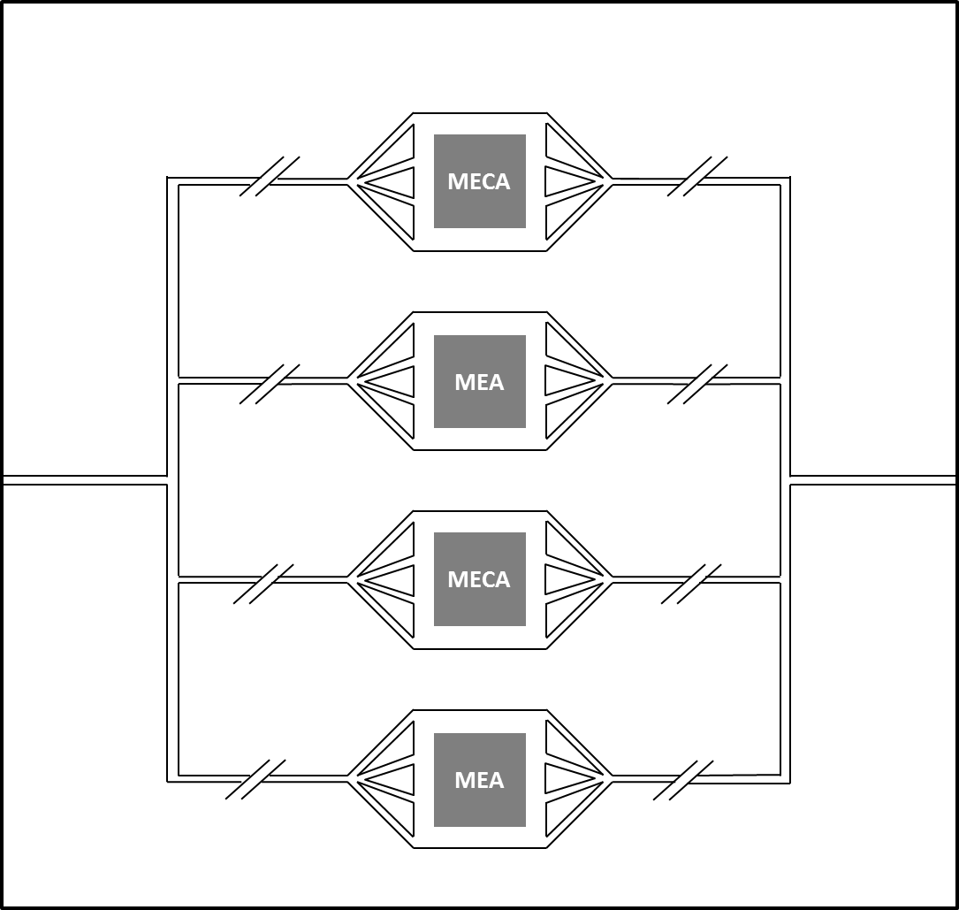
Figure 5 - General layout of the device. Side view(a) and top view(b)

Design Schedule
Now that the chamber dimensions have been calculated and the design solution has been selected, future progress on the project will be done as a group. The next step of the project is to finalize all the design elements and consult with the client to ensure satisfaction. Ideally, this will be done before November 2nd. After that, a CAD model for the chip will be created, which will be sent to the client. This should be done by November 23rd, after which the final report and presentation will be the final step of the project. A detailed design schedule is shown in Figure 5.
Task/Milestones | 19-Oct | 26-Oct | 2-Nov | 9-Nov | 16-Nov | 23-Nov | 30-Nov | 7-Dec
Progress Report
Oral Report
Chamber Dimensions
Channel Dimensions
Physical Layout
CAD Drawings
3D Printing
Final Report
Oral Report

Figure 6-GANTT Chart detailing future development of the project

References
- Smith, Alec ST, et al. "Microphysiological systems and low-cost microfluidic platform
with analytics." Stem cell research & therapy 4.Suppl 1 (2013): S9.
- Esch, Mandy et al. “Promises, challenges and future directions of mCCAs” Journal of
Biotechnology 148 (2010) 64-69
- Wilson, Kerry, et al. "Measurement of contractile stress generated by cultured rat
muscle on silicon cantilevers for toxin detection and muscle performance
enhancement." PloS one 5.6 (2010): e11042.
- Sin, Aaron, et al. "The design and fabrication of three‐chamber microscale cell culture
analog devices with integrated dissolved oxygen sensors."Biotechnology progress 20.1 (2004): 338-345.
- Sung, Jong Hwan, and Michael L. Shuler. "A micro cell culture analog (µCCA) with 3-D
hydrogel culture of multiple cell lines to assess metabolism-dependent cytotoxicity of anti-cancer drugs." Lab on a Chip 9.10 (2009): 1385-1394.
- Sung, Jong Hwan, Carrie Kam, and Michael L. Shuler. "A microfluidic device for a
pharmacokinetic–pharmacodynamic (PK–PD) model on a chip." Lab on a Chip 10.4 (2010): 446-455.
- Bianconi, Eva, et al. "An estimation of the number of cells in the human body."Annals of
human biology 40.6 (2013): 463-471.
- Dobson, Ernest L., et al. "The Measurement of Liver Circulation by Means of the
Colloid Disappearance Rate I. Liver Blood Flow in Normal Young Men. "Circulation 7.5 (1953): 690-695.
- Klabunde, Richard. Cardiovascular physiology concepts. Lippincott Williams & Wilkins,
2011: 164-168.
- Guyton, Arthur C. – Hall, John E.. Textbook of medical physiology. 11th edition.
Philadelphia : Elsevier Saunders, 2006. Chapter 21: Coronary Circulation.
- Tomlinson, B. E., and Dorothy Irving. "The numbers of limb motor neurons in the
human lumbosacral cord throughout life." Journal of the neurological sciences
34.2 (1977): 213-219.
- Oh, Kwang et al. “Design of pressure-driven microfluidic networks using electric circuit
analogy” Lab Chip 12 (2012) 515-545
- Davies, Brian, and Tim Morris. “Physiological Parameters in Laboratory Animals and
Humans.” Pharmaceutical Research 10.7(1993) 1093-1095.

